Food products recall are major threat to food companies, which may lead to bankruptcy in a series case. So what are the impact of a food recall, or group of recalls to companies? And what strategies companies could implement in order to mitigate the chances of recall events occurring?

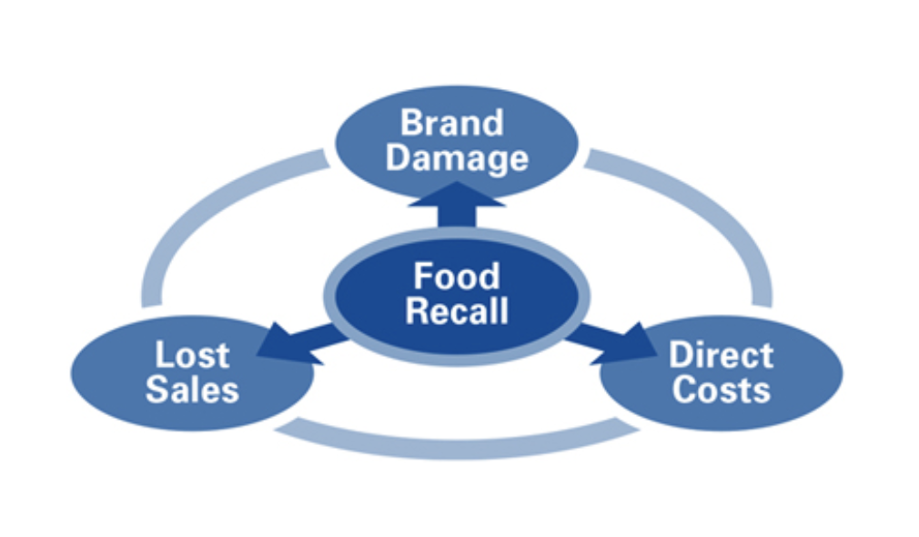

A recall event can cause devastating financial cost. For instance, Westland/Hallmark was forced by the USDA to recall the largest amount of beef in U.S. history, even though the beef has the remote probability to cause any health issues. The amount of beef, 143 million pounds of beef, which equals two year worth of processing and production.[1] In addition, the average cost of a recall to a food company is $10M in direct costs, according to a joint industry study by the Food Marketing Institute and the Grocery Manufacturers Association.[[2]](https://www.foodsafetymagazine.com/signature-series/recall-the-food-industrys-biggest-threat-to-profitability/)

A recall event can also dramatically threaten companies’ market value and brand reputation based on the fact that FSIS announces the public through a Recall Release for Class I and Class II recall, which account for more than 90% of total number of food recall events.

In addition to direct financial costs and damage of brank reputation, there are more significant costs to the food companies such as litigation costs, lost sales, the costs from any agreed or mandated governmental oversight post­ incident.

http://moneyinc.com/biggest-food-recalls-u-s-history/

https://www.foodsafetymagazine.com/signature-series/recall-the-food-industrys-biggest-threat-to-profitability/

1. http://moneyinc.com/biggest-food-recalls-u-s-history/
2. https://www.foodsafetymagazine.com/signature-series/recall-the-food-industrys-biggest-threat-to-profitability/